Table 1. Comparison chart of observed prominent MALDI peaks and calculated masses of significant proteins in Cutibacterium spectra. acn IA₁: C. acnes subsp. acnes type IA₁, acn IB: C. acnes subsp. acnes type IB, acn II: C. acnes subsp. defendens type II, acn III: C. acnes subsp. elongatum type III, mod: C. modestum, nam: C. namnetense, avi: C. avidum, gra: C. granulosum. Obs.: Observed m/z. Calc.: Calculated m/z. ND: Not detected. NP: Not present.

Protein name |  | Species/subspecies
 |  | acn IA₁ | acn IB | acn II | acn III | mod | nam | avi | gra
Putative sheep haemoglobin | Calc. | 15033.17 | 15033.17 | 15033.17 | 15033.17 | 15033.17 | 15033.17 | 15033.17 | 15033.17
alpha chain -Met [M+H]⁺ | Obs. | 15041.93 | 15047.06 | 15045.41 | 15045.67 | ND | 15041.64 | 15052.29 | 15046.48
50S ribosomal prot L7/L12 -Met [M+H]⁺ | Calc. | 13571.41 | NP | 13571.41 | 13626.48 | 13586.42 | 13529.37 | 13572.39 | 13602.42
 | Obs. | 13565.43 | ND | ND | ND | 13583.00 | ND | 13575.42 | 13601.29
Lsr2-like prot -Met [M+H]⁺ | Calc. | 11651.76 | 11651.76 | 11651.76 | 11651.76 | 11712.76 | 11724.81 | 11629.67 | 11582.72
 | Obs. | 11646.05 | 11649.39 | 11651.38 | 11648.23 | 11708.91 | ND | 11623.58 | 11581.71
10 kD Chaperonin GroS -Val [M+H]⁺ | Calc. | 10497.97 | 10497.97 | 10497.97 | 10497.97 | 10510.02 | 10497.97 | 10525.98 | 10497.97
 | Obs. | 10493.82 | 10496.39 | 10495.79 | 10496.60 | 10507.86 | ND | ND | 10495.91
DNA-binding prot HU [M+H]⁺ | Calc. | 9589.07 | 9589.07 | 9589.07 | 9589.07 | 9529.96 | 9529.02 | 9514.99 | 9601.09
 | Obs. | 9586.01 | 9587.65 | 9587.41 | 9589.36 | 9528.55 | 9527.97 | 9518.68 | 9600.35
Putative sheep haemoglobin | Calc. | 7517.09 | 7517.09 | 7517.09 | 7517.09 | 7517.09 | 7517.09 | 7517.09 | 7517.09
alpha chain -Met [M+2H]²⁺ | Obs. | 7523.20 | ND | 7523.96 | ND | 7524.36 | 7524.85 | 7527.10 | 7524.27
CsbD-like prot -Val/-Met [M+H]⁺ | Calc. | 7179.95 | 7179.95 | 7251.03 | 7237.98 | 7424.24 | 7283.97 | 7369.07 | NP
 | Obs. | 7179.01 | 7179.61 | 7250.54 | 7238.00 | 7424.35 | 7285.33 | 7372.75 | ND
7 kD Antitoxin -Met [M+H]⁺ | Calc. | 7034.57 | 7004.55 | 6985.50 | 6971.52 | 6986.53 | 6940.46 | 7043.62 | 7017.54
 | Obs. | 7033.48 | 7002.77 | 6985.48 | 6969.34 | 6986.52 | 6939.36 | 7047.01 | 7017.81
50S ribosomal prot L7/L12 -Met [M+2H]²⁺ | Calc. | 6786.21 | NP | 6786.21 | 6813.75 | 6793.72 | 6765.19 | 6786.70 | 6801.72
 | Obs. | 6785.03 | ND | 6786.62 | ND | 6793.46 | ND | ND | 6801.65
Lsr2-like prot -Met [M+2H]²⁺ | Calc. | 5826.39 | 5826.39 | 5826.39 | 5826.39 | 5856.89 | 5862.91 | 5815.34 | 5791.87
 | Obs. | 5825.25 | 5826.89 | 5825.46 | 5824.34 | 5856.20 | ND | 5813.98 | 5791.43
DUF3117 domain-containing protein | Calc. | 5712.64 | 5712.64 | 5712.64 | 5754.72 | 5692.65 | 5708.65 | 5678.58 | 5686.60
-Met [M+H]⁺ | Obs. | 5712.45 | 5711.39 | 5710.68 | 5753.77 | 5692.28 | ND | 5681.95 | 5686.97
10 kD Chaperonin GroS -Val [M+2H]²⁺ | Calc. | 5249.49 | 5249.49 | 5249.49 | 5249.49 | 5255.52 | 5249.49 | 5263.50 | 5249.49
 | Obs. | 5248.94 | 5248.13 | 5247.38 | 5248.20 | 5255.26 | ND | ND | 5250.86
DNA-binding prot HU [M+2H]²⁺ | Calc. | 4795.04 | 4795.04 | 4795.04 | 4795.04 | 4765.48 | 4765.01 | 4758.00 | 4801.05
 | Obs. | 4793.57 | 4792.28 | 4793.29 | 4794.08 | 4764.56 | 4762.25 | 4760.70 | 4801.21
CsbD-like prot -Val/-Met [M+2H]²⁺ | Calc. | 3590.48 | 3590.48 | 3626.02 | 3619.50 | 3655.58 | 3584.95 | 3627.50 | NP
 | Obs. | 3587.20 | 3587.20 | 3622.35 | 3616.04 | ND | ND | ND | ND
7 kD Antitoxin -Met [M+2H]²⁺ | Calc. | 3517.79 | 3502.78 | 3493.26 | 3486.27 | 3493.77 | 3470.74 | 3522.32 | 3509.28
 | Obs. | 3513.32 | 3497.88 | 3489.62 | 3496.78 | 3490.74 | ND | ND | 3508.86

Table 2. Comparison chart of observed prominent MALDI peaks and calculated masses of significant proteins in Staphylococcus spectra. aur: S. aureus, capi capi: S. capitis subsp. capitis, capi urea: S. capitis subsp. urealiticus, capr: S. caprae, epi: S. epidermidis, hom S. hominis, lug: S. lugdunensis. Obs.: Observed m/z. Calc.: Calculated m/z. ND: Not detected. NP: Not present.

Protein name |  | Species/subspecies
 |  | aur | capi capi | capi urea | capr | epi | hom | lug
Putative sheep haemoglobin | Calc. | 15033.17 | 15033.17 | 15033.17 | 15033.17 | 15033.17 | 15033.17 | 15033.17
alpha chain -Met [M+H]⁺ | Obs. | 15042.92 | 15046.25 | 15043.91 | 15044.56 | 15042.32 | 15041.76 | 15043.53
50S ribosomal prot L7/L12 -Met [M+H]⁺ | Calc. | 12580.36 | 12533.27 | 12533.27 | 12533.27 | 12519.25 | 12532.23 | 12475.18
 | Obs. | 12577.10 | 12530.38 | ND | 12531.30 | ND | 12526.23 | ND
30S ribosomal prot S15 -Met [M+H]⁺ | Calc. | 10478.07 | 10477.08 | 10477.08 | 10478.07 | 10507.11 | 10521.14 | 10409.99
 | Obs. | 10479.53 | 10474.45 | 10473.15 | 10480.77 | 10501.76 | 10515.16 | 10409.12
30S ribosomal prot S16 -Met [M+H]⁺ | Calc. | 10104.68 | 10192.69 | 10192.69 | 10229.76 | 10229.76 | 10172.74 | 10217.85
 | Obs. | 10101.38 | 10193.03 | 10190.21 | 10226.78 | 10227.07 | 10106.73 | 10213.89
DNA-binding prot HU [M+H]⁺ | Calc. | 9627.02 | 9641.09 | 9641.09 | 9627.02 | 9627.02 | 9656.04 | 9643.07
 | Obs. | 9624.58 | 9639.03 | 9639.62 | 9625.35 | 9625.37 | 9653.78 | 9640.08
Putative sheep haemoglobin | Calc. | 7517.09 | 7517.09 | 7517.09 | 7517.09 | 7517.09 | 7517.09 | 7517.09
alpha chain -Met [M+2H]²⁺ | Obs. | 7523.76 | 7524.89 | 7524.35 | 7524.22 | 7522.63 | 7522.85 | 7522.40
CsbD-like prot -Met [M+H]⁺ | Calc. | 6888.51 | 6711.31 | 6711.31 | 7045.60 | 6681.33 | 6476.11 | 7355.01
 | Obs. | 6888.04 | 6711.29 | 6712.02 | 7045.60 | 6679.67 | 6473.92 | 7353.52
50S ribosomal prot L32 -Met [M+H]⁺ | Calc. | 6354.36 | 6371.39 | 6371.39 | 6385.41 | 6398.41 | 6398.41 | 6371.39
 | Obs. | 6353.70 | 6370.44 | 6371.43 | 6385.44 | 6396.83 | 6396.33 | 6370.26
5.5 kD Hypothetical prot -Met [M+H]⁺ | Calc. | 5525.00 | 5098.48 | 5098.48 | 5213.52 | 5338.87 | 5237.68 | 5165.57
 | Obs. | 5524.85 | 5098.60 | 5098.86 | 5213.87 | 5337.31 | 5236.04 | 5164.67
Glycopeptide resistance- | Calc. | 5032.49 | 5041.45 | 5041.45 | 5014.38 | 5112.57 | 4564.92 | 4953.38
. associated prot GraF –Met [M+H]⁺ | Obs. | 5032.46 | 5041.61 | 5041.85 | 5015.48 | 5111.36 | 4563.08 | 4952.56
DNA-binding prot HU [M+2H]²⁺ | Calc. | 4814.02 | 4821.05 | 4821.05 | 4814.02 | 4814.02 | 4829.03 | 4822.04
 | Obs. | 4813.80 | 4822.65 | 4821.11 | 4812.46 | 4813.13 | 4827.57 | 4821.12
50S ribosomal prot L36 [M+H]⁺ | Calc. | 4306.37 | 4292.34 | 4292.34 | 4292.34 | 4292.34 | 4292.34 | 4292.34
 | Obs. | 4305.95 | 4292.22 | 4292.43 | 4292.43 | 4290.37 | 4290.72 | 4291.35
CsbD-like prot -Met [M+2H]²⁺ | Calc. | 3444.76 | 3356.16 | 3356.16 | 3523.31 | 3341.17 | 3238.56 | 3678.01
 | Obs. | 3443.31 | 3356.11 | 3355.13 | 3522.30 | 3338.78 | 3236.21 | 3676.55

Figure S1. Identification of ORFs encoding GraF in Staphylococcus strains. A. Flanking region of the GraF gene. The GraF gene is located between two ORFs encoding ‘Hypothetical protein’ and ‘ECF transporter S component’ in the genome of DSM 20231^{T}. The GenBank IDs for the genomic sequences and the locations of the predicted GraF gene in the strains, DSM 6717^{T}, NCTC 12196^{T}, and NCTC 11320^{T}, were shown below. B. An alignment of predicted amino acid sequences of GraF. Sequence similarity scores (%) to the GraF protein in DSM 20231^{T} were shown right.
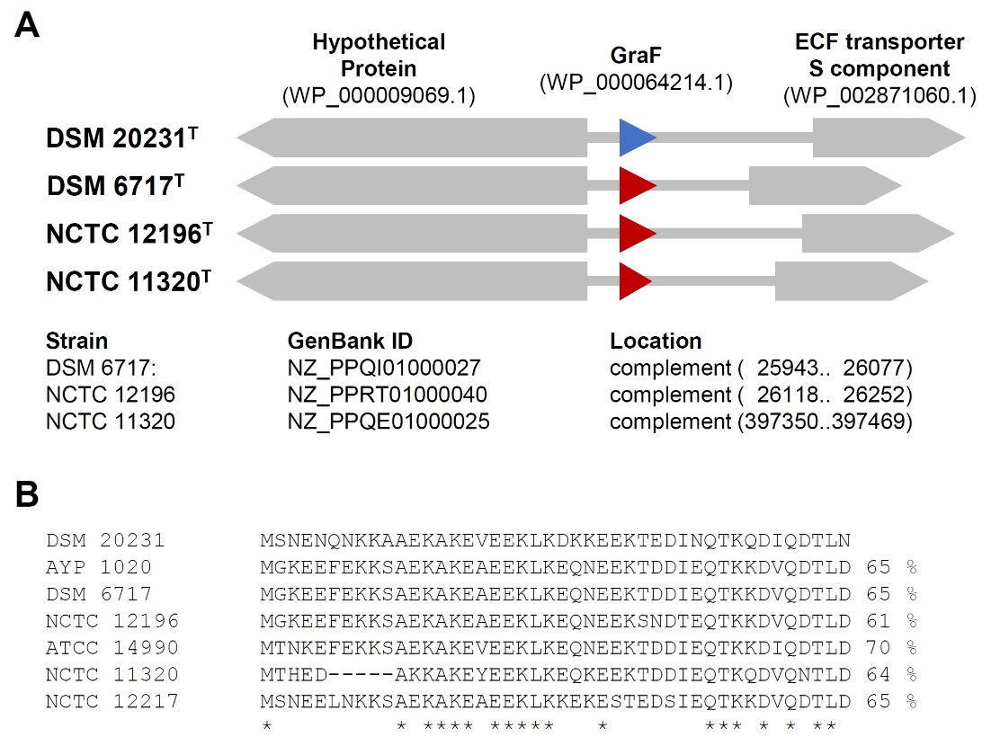

Reference
- Becher D, Hempel K, Sievers S, Zühlke D, Pané-Farré J, OttoA, Fuchs S, Albrecht D, Bernhardt J, Engelmann S, Völker U, van Dijl JM, Hecker M. 2009. A proteomic view of an important human pathogen – towards the quantification of the entire Staphylococcus aureus proteome. PLoS ONE 4: e8176. doi: 10.1371/journal.pone.0008176.

